THE FUNCTIONS OF THE FORESKIN

SEXUAL FUNCTIONS
- The foreskin is erogenous tissue, with dense concentrations of Meissner’s corpuscles (sexually sensitive fine-touch nerve endings). The glans contains relatively few fine-touch nerve endings.
- The foreskin fold provides sufficient skin length to accommodate penis growth and allow for comfortable erections.
- The mobile fold of the foreskin acts as a linear bearing, allows for a gliding action with penetration and the motions of intercourse.
- The foreskin cuff helps retain natural sexual lubrication.
- By reducing friction in these ways, the foreskin makes sex more comfortable for both partners.
- The self-stimulating interaction of the foreskin and the glans allows for closer and gentler contact between partners with the motions of intercourse.
- Possibly because of this closer contact, women report greater ease of orgasm with vaginal sex with intact men.

PROTECTIVE FUNCTIONS
- The foreskin protects the glans from chemical irritation, mechanical abrasion, and keratinization, keeping it soft, moist, and comfortable throughout life.
- The foreskin protects the delicate urinary opening from irritation and inflammation. Because of the loss of the foreskin’s protection, meatal stenosis is typically found only in circumcised males.
- The muscle fibers in the foreskin act as a sphincter, keeping out foreign matter.
- The foreskin is self cleaning; every time the child or man urinates, the orifice is flushed outward.
- The rich vascular beds in the foreskin keep the glans warm in cold conditions.
- The moisture under the foreskin contains lysozyme, an immunologically active substance.
- Langerhans cells in the foreskin secrete Langerin, a protein which conducts viruses to organelles for destruction.
- Plasma cells in the foreskin secrete immunoglobulins into the space under the foreskin.

Plus other sexual or protective functions not yet known or understood.

Circumcision alters all of these functions.
The AAP circumcision statement mentions NONE of them!

References available at: www.cirp.org
Developed by Gillian Longley RN, BSN, MSS www.ColoradoNOCIRC.org Revised March 2013
Selected recent articles on
THE SEXUAL FUNCTIONALITY OF THE FORESKIN

Sorrells et al. Fine-touch pressure thresholds in the adult penis. British Journal of Urology. 2007;99:864-869.
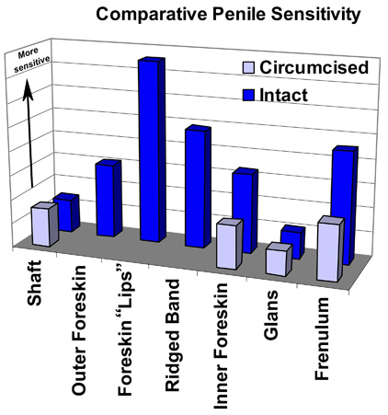

SORRELLS CONCLUSION: Circumcision removes the most sensitive parts of the penis. The glans is the least light-touch-sensitive part of the penis.

Kim D, Pang MG. The effect of male circumcision on sexuality. British Journal of Urology. 2007 Mar;99(3):619-22.
CONCLUSION: There was a decrease in masturbatory pleasure and sexual enjoyment after circumcision, indicating that adult circumcision adversely affects sexual function in many men, possibly because of complications of the surgery and a loss of nerve endings.

Frisch et al. Male circumcision and sexual function in men and women: a survey-based, cross-sectional study in Denmark. Int J Epidemiol. 2011 Oct;40(5):1367-81.

CONCLUSION: Circumcision was associated with frequent orgasm difficulties in Danish men and with a range of frequent sexual difficulties in women, notably orgasm difficulties, dyspareunia [painful intercourse] and a sense of incomplete sexual needs fulfillment.

Bronselaer et al. Male circumcision decreases penile sensitivity as measured in a large cohort. British Journal of Urology. 2013 Feb 4. [Epub ahead of print.]

CONCLUSIONS: This study confirms the importance of the foreskin for penile sensitivity, overall sexual satisfaction, and penile functioning. Furthermore, this study shows that a higher percentage of circumcised men experience discomfort or pain and unusual sensations as compared with the uncircumcised population. Before circumcision without medical indication, adult men, and parents considering circumcision of their sons, should be informed of the importance of the foreskin in male sexuality.

